Testing Plan for To-Do App

Prepared for: Trenz Pruca, Title

P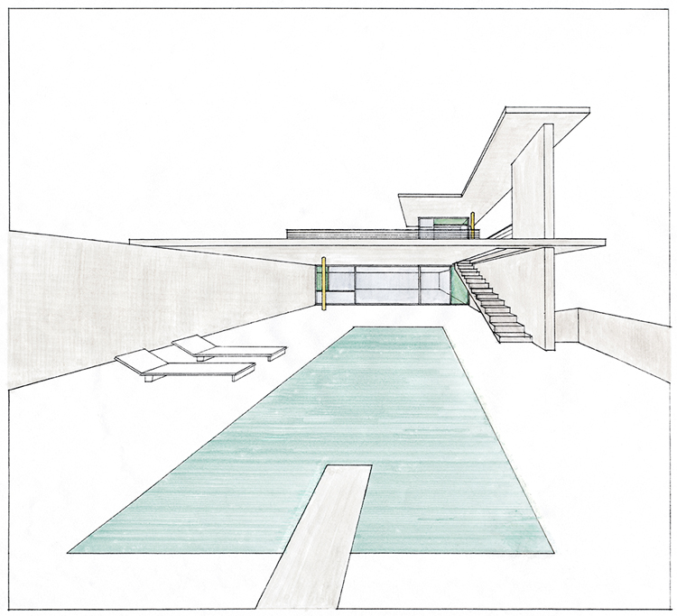repared by: Urna Semper, Job Title

company name

August 1, 2019

Proposal number: 123-4567

# Overview

## Introduction

This plan describes the testing approach that will serve as the fundamental strategy for our To-Do app. The purpose of the app is to provide the user with a single list of items that they can manage with simple actions. It will be built only for web use.

The product requirements for the To-Do app are as follows:

A user can add a new item to the list.

A user can mark an item as complete in a list.

A user can delete an item from the list.

## Features to Test

1. A user can add a new item to the list

* + Frontend:
    - User can click on call to action to add new item
    - New item appears in list after adding new item
  + Backend:

company name

* + - Calling API endpoint adds item to database that persists between sessions and return correct JSON data

2. A user can mark an item as complete in a list

* + Frontend:
    - User can click on call to action to mark an item as complete
    - Item has different visual styles applied to it when marked as complete
  + Backend:
    - Verify that API endpoint updates the status of the item between sessions and returns correct JSON data

3. A user can delete an item from a list

* + Frontend:
    - User can click on call to action to delete item
    - Existing item is removed from the page after deleting item
  + Backend:
    - Verify API endpoint removes existing item from database